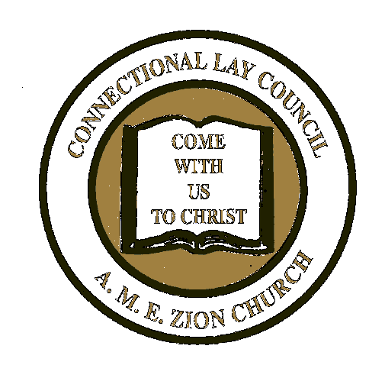
CONNECTIONAL LAY COUNCIL
Lele Davis, Special Projects
704.321.7022 (home)
704.562.0402 (cell)
Email: Lpsivad@carolina.rr.com

THE AFRICAN METHODIST EPISCOPAL ZION CHURCH

LIFE MEMBER STOLE ORDER FORM

COST: $50.00

Date ___________________________________

Episcopal District____________________________ Conference________________________ P.E. District _____________________

Local Church _______________________________ Pastor ____________________________ President_______________________

Account #  Or New | Name | Address | City/State/Zip Code | Amount  Paid

Shipping ($2.50 per stole) : $_____________

TOTAL AMOUNT DUE: $_____________
CONTACT INFORMATION:

Name _________________________________ Address _______________________________ City/State/Zip ____________________________

Email Address ______________________________________ Contact Phone Number_________________________

Mail Form and payment to: Connectional Lay Council P.O. Box 26770 Charlotte, NC 28221 Office#: 704.599.4630 x2566

