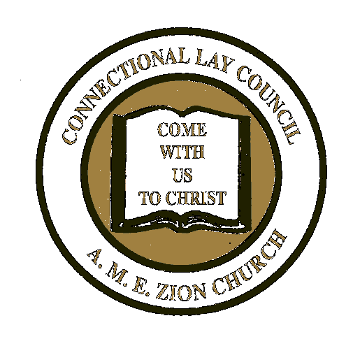**CONNECTIONAL LAY COUNCIL**

**CLC Special Projects**

**704.599.4630 Ext 2566 office**

**Email: CLCOffice@AMEZHqtr.org**

**THE AFRICAN METHODIST EPISCOPAL ZION CHURCH**

**LIFE MEMBER STOLE ORDER FORM**

**COST: $50.00**

**Date ___________________________________**

**Episcopal District____________________________ Conference________________________ P.E. District _____________________**

**Local Church _______________________________ Pastor ____________________________ President_______________________**

|  |  |  |  |  |
| --- | --- | --- | --- | --- |
| **Account #**  **Or New** | **Name** | **Address** | **City/State/Zip Code** | **Amount**  **Paid** |
|  |  |  |  |  |
|  |  |  |  |  |
|  |  |  |  |  |
|  |  |  |  |  |
|  |  |  |  |  |
|  |  |  |  |  |
|  |  |  |  |  |
|  |  |  |  |  |
|  |  |  |  |  |
|  |  |  |  |  |
|  |  |  |  |  |
|  |  |  |  |  |

**Shipping ($2.50 per stole) : $_____________**

**TOTAL AMOUNT DUE: $_____________**

**CONTACT INFORMATION:**

**Name _________________________________ Address _______________________________ City/State/Zip ____________________________**

**Email Address ______________________________________ Contact Phone Number_________________________**

**Mail Form and payment to: Connectional Lay Council P.O. Box 26770 Charlotte, NC 28221 Office#: 704.599.4630 x2566**